Ozone Bio-Indicator Field Study Report
Identify plant species being studied: ___________________________
Describe location where plant was found or planted: _________________________
Position of leaf on plant: Row ____ (# of row, counting down from top) of ____ (list total # leaf rows)

Observations
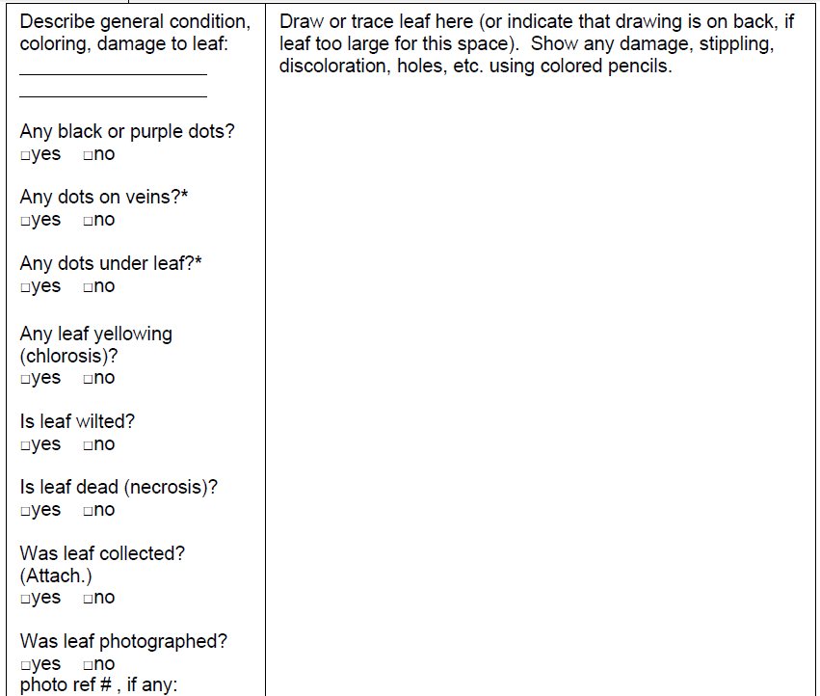

Data
Approximately what percentage of the leaf is affected by ozone stippling, if any? ____________

Conclusions
Has ozone air pollution affected this community of organisms (ecosystem)? □yes □no
What evidence supports your conclusion?
______________________________________________________________________________

