Grades: 8th Grade

Overview: This interactive lab illustrates the effects of lighting on our view of the night sky and how shielding can reduce light pollution while at the same time making the lighting more effective. This is an application of electromagnetic radiation and materials.

Purpose: To evaluate light shielding using materials that are materials that minimize light pollution.

Objectives: Using the materials, students will explore the “light footprint” of an unshielded light, make observations on the effect of the light, think about potential problems of an unshielded light, design a solution to solve as many of these problems as possible, then build their solution from a variety of commonly found items that can be classified as transparent, translucent, or opaque.

Time: An entire class period (roughly 60 minutes). Background on light pollution should be presented prior to doing the lab with students.

Materials and Tools:
- “Mini-lights” (such as the Mini Maglite flashlight), one for each group of students
- City mat, one for each group of students see pdf.
- Play-Doh (enough to make a base for the flashlight for each group, plus extra
- Miscellaneous materials such as straws, popsicle sticks, tape (assorted kinds), aluminum foil, paper (assorted kinds), wooden skewers, paper/plastic cups (assorted sizes), etc.
- Lab notebook or worksheets for students

Preparation/Prerequisites:

This lab should be done immediately after the explore portion of the lesson so that students connect the shielding of different types of radiation using materials. Students should use their knowledge of shielding natural light to do the same to artificial. This lab is best done when in a completely darkened room (e.g., no light). A room without windows is recommended. If a room with windows must be used, the windows can be covered with black trash bags (2 layers per window are very effective). The time required to cover the windows will depend on the number of windows.

Setting up the lab itself only takes 5 minutes. It is best to have enough lab stations set up so that there are no more than 5 students per group.

The mini-lights should have their reflectors taken off, exposing the bulb (which is very fragile and can be hot). This “mode” allows the mini- lights to be streetlights. The mini-lights should be secured with a Play-doh base so that they do not get knocked over as easily. The structure designed by the students should be free standing (i.e. not attached to the mini-light). The Play-Doh can also be used a base for the structure. You may also use a UV light.

Background Information/Links:

All materials for this lesson and other Dark Skies Rangers activities are available at http://www.globeatnight.org/dsr/.

There are three main types of light pollution:

- Glare is too much background light. Can you see the stop sign or read the sign below it in this image?
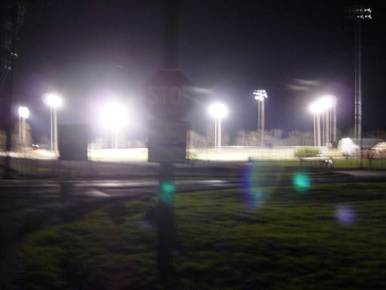
- Light trespass is light that spills into an area where it is unwanted. Would you be able to sleep if your bedroom window faced this neighbor’s light?
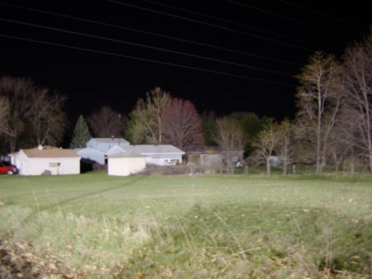

- Sky glow is lots of light scattering off particles in the air, giving the appearance of a glowing sky. Do you see any stars in this image?
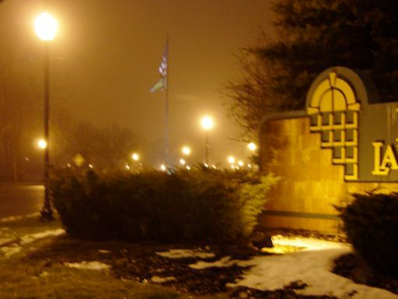

Image credit: Chuck Bueter of nightwise.org

More background on light pollution can be found on the Globe at Night website:
http://www.globeatnight.org/light-pollution.php

Quality lighting should:

- Maximize the desired effects:
  - Good vision
  - Good night ambiance
- Minimize the adverse effects:
  - Energy waste
  - Glare
  - Light trespass
  - Sky glow
Keys to quality lighting:

- Shine the light down.
- See the effect, not the source (e.g., no glare).
- Light only where and when needed.
- Don’t over-light.
- Use energy efficient sources.

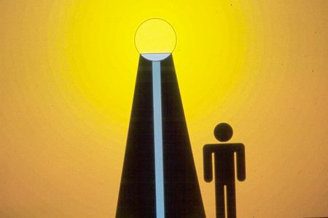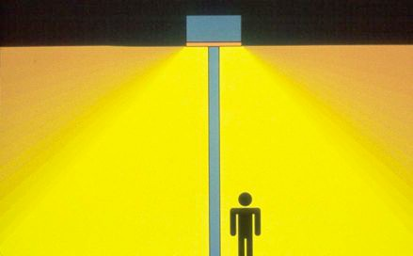
Shielding can maximize the desired effects of lighting by controlling the light output and minimizing the glare, light trespass, and light that travels straight up, as illustrated below.

Unshielded fixture Shielded fixture

Lesson Sequence (For Teacher):

Activator: Read/discuss with the class There Once Was a Sky Full of Stars (book by Bob Crelin): If Available
Instructional Strategies: See lesson plan sequence below.
Summative Assessment: Students survey home or neighborhood lighting for examples of good and bad lighting. Doing the Light Shielding Lab:
- Make sure you are in a very dark room with a low ceiling. Set up the activity on tables with a city mat and mini-light
(Mounted in Play-Doh) at each lab station.

- Unscrew the reflectors from the mini-lights and turn them on.

- With the students working in groups of no more than 5, have them make 5-10 observations about the scenario in front of them. Have them write their observations in their lab notebook or in a spiral.

- Ask the students to think of 5-10 problems that they see with the scenario.

- Ask the students to think of ways to solve the problems they thought of. Have them think especially about a solution that would solve more as many of the problems at once.

- Have the students make a “Prototype 1” sketch of their solution in their notebook.

- Using the materials in the “Light Shielding Lab” kit, have the students build their solutions. Anything they build cannot be directly attached to or touching the mini-light; this is to avoid break the mini-lights.

- Have the students test their solutions. Is there a design that will work better?

- Have the students make a “Prototype 2” sketch with any revisions they made to their original design.

- Optional: Do the Light Pollution and Shielding Demonstration using one of the “shields” built by the students.

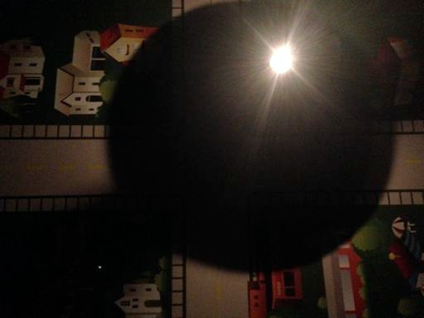
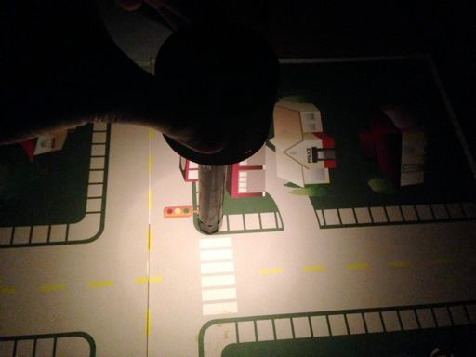
- Optional: Give the students a certain amount of “currency” that they are allowed to spend, and set a “price” for each type and amount of building materials. Declare that some materials (like Play-Doh) are non-renewable resources and must be used wisely.

Teacher Resources

Questions:

Besides the questions throughout the lesson sequence, have the students discuss their observations and the benefits of shielded lighting. Note that shielded lighting improves our view of the stars (reduces sky glow), and is safer and more energy efficient, since it directs light down to the ground, where we want lighting rather than up into the sky. This improves the quality of life for people, animals, and plants; saves money and energy; and preserves our beautiful dark skies.

Integration:

Content reading skills (cause/effect, main idea/details, or vocabulary) may be reinforced using either online or offline reading materials to increase the effectiveness of this lesson. Vocabulary like the types of light pollution can also be introduced or reinforced while demonstrating the activity with the students’ solutions.

Extensions:

You may want to encourage the students to take part in citizen science projects to measure light pollution (see resources below) and to write letters to the local newspaper, government, and businesses to encourage the installation of shielded lighting in their community.

Online Resources:

- A simple demonstration illustrating glare, light trespass, and sky glow shows how light pollution can be remedied by shielding outdoor lights – http://www.youtube.com/watch?v=nb7eryzSBno
- A video demonstration to understand light pollution and their effects on our environment–
http://www.youtube.com/watch?v=dd82jaztFIo
- Globe at Night – http://www.globeatnight.org/
- International Dark Sky Association – http://www.darksky.org/
- Astronomical League – http://www.astroleague.org
- Astronomers Without Borders – http://www.astronomerswithoutborders.org/
- American Astronomical Society – http://www.aas.org
- Astronomical Society of the Pacific – http://www.astrosociety.org
- The Let There Be Night Program – http://www.lettherebenight.org
- Unihedron, the makers of the Sky Quality Meter – http://www.unihedron.com
- National Park Service Dark Sky Team – http://www2.nature.nps.gov/air/lightscapes/
- On Light Pollution: http://en.wikipedia.org/wiki/Light_pollution and http://www.globeatnight.org/learn_light.html
- On Light Pollution Interactive: http://www.globeatnight.org/learn_orionsky.html
- On Apparent Magnitude: http://en.wikipedia.org/wiki/Apparent_magnitude
- On Stellar Magnitude System: http://www.skyandtelescope.com/howto/basics/Stellar_Magnitude_System.html
- On Limiting Magnitude: http://en.wikipedia.org/wiki/Limiting_magnitude
- On Sky Brightness: http://en.wikipedia.org/wiki/Sky_brightness
- On Skyglow: http://en.wikipedia.org/wiki/Skyglow

