Part 1 Set-up: Choose “Motion”
- Check boxes:
- Move the Applied Force sliders.
- Change the masses.

PhET Forces Motion html5
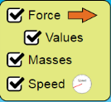
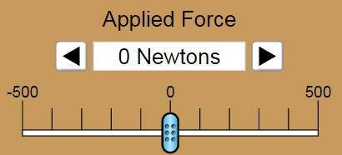
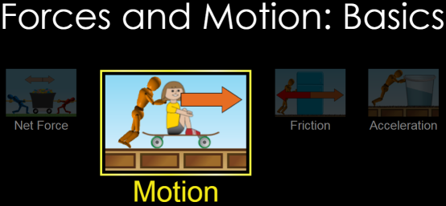



Part 2 Directions: How does the mass affect the speed? For 4 different masses record the top speed.
Masses:  Total: | Top Speed: 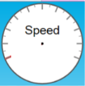
Masses:  Total: | Top Speed:
Masses:  Total: | Top Speed:
Masses:  Total: | Top Speed:
In a few sentences, compare and contrast what you found in the table above for each of the different masses, including any observations you had about how you arrived at the top speed. (examples of observations: It was easier/harder to get to top speed? Top speed was slower/faster? It took longer/shorter to get tot top speed, etc.)?

How can you find out what the “mystery mass” is? Write down your ideas (steps to follow?) on how to find the mass here:


What is the mass of the mystery mass? (Show math or give word support for your answer)

